# 

# NibblesBot: Project Requirements

By Ethen Carrell, Charles Moertle, and Calab Reeder

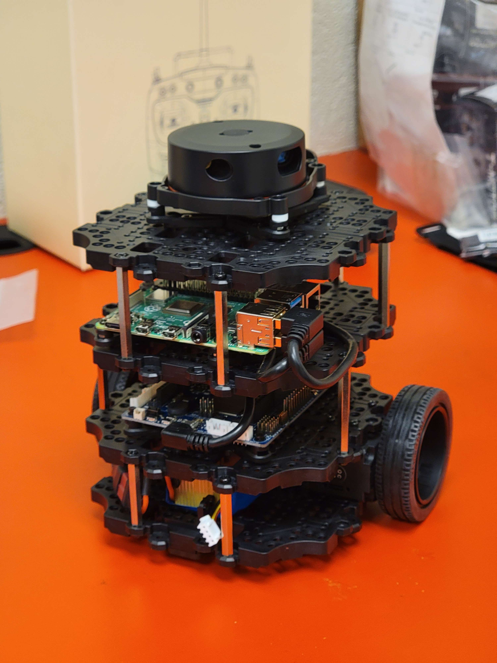

## Table of Contents

Page #

**Project Name** **2**

**Team Member Names**  **2**

**Abstract** **2**

**Tools and Technology** **2**

**Requirement List 2**

Software Installation

Robot Hardware Modifications

Verify all Hardware Integrity

Engineering the Environment

Computer Vision (OpenCV)

Arranging Children’s Blocks

**Updated Timeline 3**

**Appendix 4**

Figure 1: Team Member Names

Figure 2: Nibblesbot Tech-Stack

Figure 3: Timeline

## Project Name

The name **NibblesBot** comes from a pet turtle.

## Team Member Names

See figure 1 in Appendix

## Abstract

Our team will use the TurtleBot3 Burger to rearrange several children’s blocks into a specified order. To accomplish this task, we will assemble the mobile robot and modify it to suit the assignment. The first planned modification involves affixing a camera to the front of the robot which will allow for accurate readings of the top of the children’s blocks. Using this information along with additional images from a camera suspended above the map, the robot will calculate an appropriate path to move in order to sort the blocks, before moving in order to accomplish this task.

## 

## Tools & Technologies

See figure 2 in Appendix

## Requirements List

1. Software Installation
   1. Installing Ubuntu
      1. One installation will be done for each team member’s laptop
         1. Oracle VirtualBox will be used to run the Ubuntu OS
      2. Another installation will be done for the robot’s Raspberry Pi 4
         1. Ubuntu will be the main OS so it will not need a virtual machine
   2. Installing ROS Noetic
      1. One installation will be done for each member’s laptop
         1. It will be installed in the virtual Ubuntu OS
      2. Another installation will be done for the robot’s Raspberry Pi 4
   3. Installing PyCharm as designated IDE
      1. Some needed libraries…
         1. SciPy
         2. OpenCV
2. Robot Hardware Modifications
   1. Install 3d printed scoop for moving blocks
   2. Mount camera to the front of the robot
      1. Camera will be facing downwards at an angle to capture what the robot is pushing
3. Verify all Hardware Integrity
   1. Confirm the robot’s wheel motors work properly
   2. Confirm the camera can properly read the top of each colored block
      1. This only concerns blocks immediately in front of or being pushed by the robot
   3. Confirm the battery holds charge for expected duration of time
      1. Expected operating time: 2h 30m
   4. Confirm the 3d printed scoop can accurately move the blocks…
      1. In a corner
      2. Next to a wall
      3. In the open
      4. Next to other blocks
4. Engineering the Environment
   1. External Camera with bird’s eye of the area
      1. The camera will be deployed on a tripod
   2. Build walls surrounding the activity area of the robot
      1. Demarcations will be made using black tape
5. Computer Vision (OpenCV)
   1. Create objects based around each colored block on the map
      1. The location of each block will be stored as a coordinate in the object
         1. Coordinates will be made using the bird’s eye view camera
      2. The letter or number at the top of the block will be stored as a string in the object
         1. Top of the block will be recorded using camera on the robot
   2. Constantly check orientation of robot
   3. Designate area to arrange the blocks
6. Arranging Children’s Blocks
   1. Arrange blocks in specified order
      1. Avoiding the use of Z and N, as well as M and W blocks
      2. Avoiding the use of yellow colored blocks
      3. Only using the distinctly colored sides of the blocks
      4. The order will be A-Z 1-9
         1. Map may not always contain both letters and numbers
      5. Duplicated letter blocks will be placed side by side in the normal order

## Updated Timeline

See Figure 3 in appendix.

## Appendix

Figure 1: Team Member Names

| Name | Role |
| --- | --- |
| Ethen Carrell | Researcher, Programmer, Software Tester |
| Charles Moertle | Researcher, Programmer,  Technician |
| Calab Reeder | Researcher, Programmer, Project Manager |

Figure 2: NibblesBot Tech-Stack

| Tool Name | Tool Type | Why |
| --- | --- | --- |
| TheConstruct Gazebo | Simulator | Allows team members to test code without using the real robot |
| TurtleBot3 Burger | Robot | Current robot model |
| Camera (x2) | Visual Feed | To capture images for computer vision processing |
| LiDAR | Laser Sensor | LiDAR will be used to detect and avoid obstacles |
| TheConstruct ROSject | IDE | Coding environment set up in ROS environment for early stage debugging |

Figure 3: Timeline

| Week 1: January 15th - 21st | **All Members:**  Project proposal, build the robot, install Ubuntu and ROS on personal computers |
| --- | --- |
| Week 2: January 22nd - 28th | **All Members:**  Project requirements, install Ubuntu on SD card for robot, learn how to use git and github |
| Week 3: January 29th - February 4th | **Calab & Ethen:**  Research cameras to use for the project, test the robot’s hardware  **Charles:**  Install ROS on the robot and get remote access working |
| Week 4: February 5th - 11th | **All Members:**  Setup environment for robot to be tested in, install cameras and test their resolution |
| Week 5: February 12th - 18th | **Calab:**  Research and work on identifying the letters on the children’s blocks with computer vision  **Ethen:**  Work on getting the robot to approach a block once its been detected  **Charles:**  Implement and work on robot’s odometry |
| Week 6: February 19th - 25th | **Charles & Ethen:**  Build an apparatus to move blocks more accurately, attach said apparatus to the robot and test it  **Calab:**  Continue working on identifying the letters on the children’s blocks with more accuracy |
| Week 7: February 26th - March 4th | **All Members:**  Combine previous work to see where we may be lacking progress |
| Week 8: March 5th - March 11th | **Charles:**  Use the downward facing camera to give each block a coordinate location in the map  **Ethen & Calab:**  Begin arranging one to two blocks using previously made software |
| Week 9: March 12th - 18th | **Charles & Calab:**  Create objects based on each block, give each block object a coordinate and a key based on the top of the block  **Ethen:**  Work on arranging more than two blocks at once |
| Week 10: March 19th - 25th | **All Members:**  Combine everything and see if software can properly arrange all blocks on the map |
| Week 11: March 26th - April 1st | **All Members:**  Debug any issues in the software |
| Week 12: April 2nd - 8th | **All Members:**  Debug any issues in the software |
| Week 13: April 9th - 15th | **All Members:**  Prepare presentation, designate speaking roles, prepare videos for demonstration, create poster for the Innovation Experience |
| Week 14: April 16th - 22nd | ***Innovation Experience - April 21st***  **All Members:**  Practice roles, finalize presentation |
| Week 15: April 23rd - April 29th | **All Members:**  Debug current software, establish additional features to implement with remaining time |
| Week 16: April 30th - May 6th | ***Attend Graduation - May 5th***  **Charles:**  Debug added features  **Calab & Ethen:**  Attempt to implement additional features |